Image Processing Toolbox

What Is the Image Processing Toolbox?
The Image Processing Toolbox is a collection of functions that extend the capability of the MATLAB®numeric computing environment. The toolbox supports a wide range of image processing operations, including
- Spatial image transformations
- Morphological operations
- Neighborhood and block operations
- Linear filtering and filter design
- Transforms
- Image analysis and enhancement
- Image registration
- Deblurring
- Region of interest operations
Many of the toolbox functions are MATLAB M-files, a series of MATLAB statements that implement specialized image processing algorithms. You can view the MATLAB code for these functions using the statement
type function_name
You can extend the capabilities of the Image Processing Toolbox by writing your own M-files, or by using the toolbox in combination with other toolboxes, such as the Signal Processing Toolbox and the Wavelet Toolbox.
For a list of the new features in this version, see the Release Notes documentation.

Configuration Notes
To determine if the Image Processing Toolbox is installed on your system, type this command at the MATLAB prompt.
ver
When you enter this command, MATLAB displays information about the version of MATLAB you are running, including a list of all toolboxes installed on your system and their version numbers.
For information about installing the toolbox, see the MATLAB Installation Guide for your platform.
For the most up-to-date information about system requirements, see the system requirements page, available in the products area at The MathWorks Web site (www.mathworks.com).

Related Products
The MathWorks provides several products that are relevant to the kinds of tasks you can perform with the Image Processing Toolbox and that extend the capabilities of MATLAB. For information about these related products, see www.mathworks.com/products/image/related.html.

Compilability
The Image Processing Toolbox is compilable with the MATLAB Compiler except for the following two functions that launch GUIs:
- cpselect
- imtool

Example 1 — Some Basic Concepts
This example introduces some basic image processing concepts, including reading and writing images, performing histogram equalization on an image, and getting information about an image. The example breaks this process into the following steps:
- Step 1: Read and Display an Image
- Step 2: Check How the Image Appears in the Workspace
- Step 3: Improve Image Contrast
- Step 4: Write the Image to a Disk File
- Step 5: Check the Contents of the Newly Written File
Before beginning with this example, you should already have installed the Image Processing Toolbox and have started MATLAB. If you are new to MATLAB, read the MATLAB Getting Started documentation to learn about basic MATLAB concepts.

Step 1: Read and Display an Image
Clear the MATLAB workspace of any variables and close open figure windows.
clear, close all
To read an image, use the imread command. The example reads one of the sample images included with the Image Processing Toolbox, pout.tif, and stores it in an array named I.
I = imread('pout.tif');
imread infers from the file that the graphics file format is Tagged Image File Format (TIFF). For the list of supported graphics file formats, see the imread function reference documentation.
Now display the image. The toolbox includes two image display functions: imshow and imtool. imshow is the toolbox's fundamental image display function. imtool starts the Image Tool which presents an integrated environment for displaying images and performing some common image processing tasks. The Image Tool provides all the image display capabilities of imshow but also provides access to several other tools for navigating and exploring images, such as scroll bars, the Pixel Region tool, Image Information tool, and the Contrast Adjustment tool. For more information, see Displaying and Exploring Images.
You can use either function to display an image. This example uses imshow.
imshow(I)

Grayscale Image pout.tif
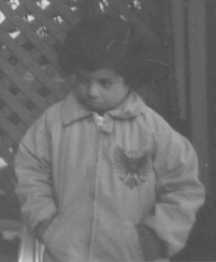

Step 2: Check How the Image Appears in the Workspace
To see how the imread function stores the image data in the workspace, check the Workspace browser in the MATLAB desktop. The Workspace browser displays information about all the variables you create during a MATLAB session. The imread function returned the image data in the variable I, which is a 291-by-240 element array of uint8 data. MATLAB can store images as uint8, uint16, or double arrays.
You can also get information about variables in the workspace by calling the whos command.
whos
Name Size Bytes Class

I 291x240 69840 uint8 array

Grand total is 69840 elements using 69840 bytes
For more information about image storage classes, see Converting Between Image Classes.

Step 3: Improve Image Contrast
pout.tif is a somewhat low contrast image. To see the distribution of intensities in pout.tif, you can create a histogram by calling the imhist function. (Precede the call to imhist with the figure command so that the histogram does not overwrite the display of the image I in the current figure window.)
figure, imhist(I)
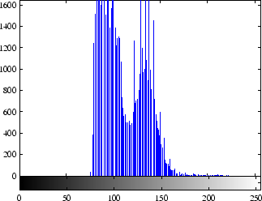
Notice how the intensity range is rather narrow. It does not cover the potential range of [0, 255], and is missing the high and low values that would result in good contrast.
The toolbox provides several ways to improve the contrast in an image. One way is to call the histeq function to spread the intensity values over the full range of the image, a process called histogram equalization.
I2 = histeq(I);
Display the new equalized image, I2, in a new figure window.
figure, imshow(I2)

Equalized Version of pout.tif
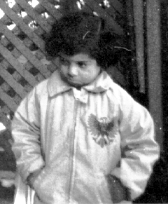
Call imhist again to create a histogram of the equalized image I2. If you compare the two histograms, the histogram of I2 is more spread out than the histogram of I1.
figure, imhist(I2)
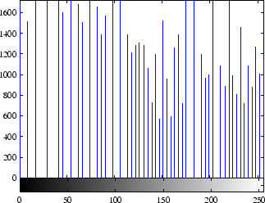
The toolbox includes several other functions that perform contrast adjustment, including the imadjust and adapthisteq functions. See Intensity Adjustment for more information. In addition, the toolbox includes an interactive tool, called the Adjust Contrast tool, that you can use to adjust the contrast and brightness of an image displayed in the Image Tool. To use this tool, call the imcontrast function or access the tool from the Image Tool. For more information, see Adjusting the Contrast and Brightness of an Image.

Step 4: Write the Image to a Disk File
To write the newly adjusted image I2 to a disk file, use the imwrite function. If you include the filename extension '.png', the imwrite function writes the image to a file in Portable Network Graphics (PNG) format, but you can specify other formats.
imwrite (I2, 'pout2.png');
See the imwrite function reference page for a list of file formats it supports. See also Writing Image Data for a tutorial discussion on writing images using the Image Processing Toolbox.

Step 5: Check the Contents of the Newly Written File
To see what imwrite wrote to the disk file, use the imfinfo function. This function returns information about the image in the file, such as its format, size, width, and height. See Getting Information About a Graphics File for more information about using imfinfo.
imfinfo('pout2.png')

ans =

Filename: 'pout2.png'
FileModDate: '29-Dec-2005 09:34:39'
FileSize: 36938
Format: 'png'
FormatVersion: []
Width: 240
Height: 291
BitDepth: 8
ColorType: 'grayscale'
FormatSignature: [137 80 78 71 13 10 26 10]
Colormap: []
Histogram: []
InterlaceType: 'none'
Transparency: 'none'
SimpleTransparencyData: []
BackgroundColor: []
RenderingIntent: []
Chromaticities: []
Gamma: []
XResolution: []
YResolution: []
ResolutionUnit: []
XOffset: []
YOffset: []
OffsetUnit: []
SignificantBits: []
ImageModTime: '29 Dec 2005 14:34:39 +0000'
Title: []
Author: []
Description: []
Copyright: []
CreationTime: []
Software: []
Disclaimer: []
Warning: []
Source: []
Comment: []
OtherText: []
imwrite
Write image to graphics file
Syntax
- imwrite(A,filename,fmt)
- imwrite(X,map,filename,fmt)
- imwrite(...,filename)
- imwrite(...,Param1,Val1,Param2,Val2...)

Description
imwrite(A,filename,fmt) writes the image A to the file specified by filename in the format specified by fmt.
A can be an M-by-N (grayscale image) or M-by-N-by-3 (color image) array. A cannot be an empty array. If the format specified is TIFF, imwrite can also accept an M-by-N-by-4 array containing color data that uses the CMYK color space. For information about the class of the input array and the output image, see Class Support.
filename is a string that specifies the name of the output file.
fmt can be any of the text strings listed in the table in Supported Formats. This list of supported formats is determined by the MATLAB image file format registry. See imformats for more information about this registry.
imwrite(X,map,filename,fmt) writes the indexed image in X and its associated colormap map to filename in the format specified by fmt. If X is of class uint8 or uint16, imwrite writes the actual values in the array to the file. If X is of class double, the imwrite function offsets the values in the array before writing, using uint8(X-1). The map parameter must be a valid MATLAB colormap. Note that most image file formats do not support colormaps with more than 256 entries.
imwrite(...,filename) writes the image to filename, inferring the format to use from the filename's extension. The extension must be one of the values for fmt, listed in Supported Formats.
imwrite(...,Param1,Val1,Param2,Val2...) specifies parameters that control various characteristics of the output file for HDF, JPEG, PBM, PGM, PNG, PPM, and TIFF files. For example, if you are writing a JPEG file, you can specify the quality of the output image. For the lists of parameters available for each format, see Format-Specific Parameters.
Supported Formats
This table summarizes the types of images that imwrite can write. The MATLAB file format registry determines which file formats are supported. See imformats for more information about this registry. Note that, for certain formats, imwrite may take additional parameters, described in Format-Specific Parameters.
Format | Full Name | Variants
'bmp' | Windows Bitmap (BMP) | 1-bit, 8-bit, and 24-bit uncompressed images
'gif' | Graphics Interchange Format (GIF) | 8-bit images
'hdf' | Hierarchical Data Format (HDF4) | 8-bit raster image data sets, with or without associated colormap, 24-bit raster image data sets; uncompressed or with RLE or JPEG compression
'jpg' or 'jpeg' | Joint Photographic Experts Group (JPEG) | 8-bit, 12-bit, and 16-bit Baseline JPEG images  Note: Indexed images are converted to RGB before writing out JPEG files, because the JPEG format does not support indexed images.
'pbm' | Portable Bitmap (PBM) | Any 1-bit PBM image, ASCII (plain) or raw (binary) encoding
'pcx' | Windows Paintbrush (PCX) | 8-bit images
'pgm' | Portable Graymap (PGM) | Any standard PGM image; ASCII (plain) encoded with arbitrary color depth; raw (binary) encoded with up to 16 bits per gray value
'png' | Portable Network Graphics (PNG) | 1-bit, 2-bit, 4-bit, 8-bit, and 16-bit grayscale images; 8-bit and 16-bit grayscale images with alpha channels; 1-bit, 2-bit, 4-bit, and 8-bit indexed images; 24-bit and 48-bit truecolor images; 24-bit and 48-bit truecolor images with alpha channels
'pnm' | Portable Anymap (PNM) | Any of the PPM/PGM/PBM formats, chosen automatically
'ppm' | Portable Pixmap (PPM) | Any standard PPM image. ASCII (plain) encoded with arbitrary color depth; raw (binary) encoded with up to 16 bits per color component
'ras' | Sun Raster (RAS) | Any RAS image, including 1-bit bitmap, 8-bit indexed, 24-bit truecolor and 32-bit truecolor with alpha
'tif' or 'tiff' | Tagged Image File Format (TIFF) | Baseline TIFF images, including 1-bit, 8-bit, 16-bit, and 24-bit uncompressed images; 1-bit, 8-bit, 16-bit, and 24-bit images with packbits compression; 1-bit images with CCITT 1D, Group 3, and Group 4 compression; CIELAB, ICCLAB, and CMYK images
'xwd' | X Windows Dump (XWD) | 8-bit ZPixmaps

Format-Specific Parameters
The following tables list parameters that can be used with specific file formats.
GIF-Specific Parameters
This table describes the available parameters for GIF files.
Parameter | Values | Default
'BackgroundColor' | A scalar integer. This value specifies which index in the colormap should be treated as the transparent color for the image and is used for certain disposal methods in animated GIFs. If X is uint8 or logical, then indexing starts at 0. If X is double, then indexing starts at 1.
'Comment' | A string or cell array of strings containing a comment to be added to the image. For a cell array of strings, a carriage return is added after each row.
'DelayTime' | A scalar value between 0 and 655 inclusive, that specifies the delay in seconds before displaying the next image.
'DisposalMethod' | One of the following strings, which sets the disposal method of an animated GIF: 'leaveInPlace', 'restoreBG', 'restorePrevious', or 'doNotSpecify'.
'LoopCount' | A finite integer between 0 and 65535 or the value Inf (the default) which specifies the number of times to repeat the animation. By default, the animation loops continuously. For a value of 0, the animation will be played once. For a value of 1, the animation will be played twice, etc. | Inf
'TransparentColor' | A scalar integer. This value specifies which index in the colormap should be treated as the transparent color for the image. If X is uint8 or logical, then indexing starts at 0. If X is double, then indexing starts at 1.
'WriteMode' | One of these strings: 'overwrite' (the default) or 'append'. In append mode, a single frame is added to the existing file. | 'overwrite'

HDF4-Specific Parameters
This table describes the available parameters for HDF4 files.
Parameter | Values | Default
'Compression' | One of these strings:  'none'  'jpeg' (valid only for grayscale and RGB images)  'rle' (valid only for grayscale and indexed images) | 'rle'
'Quality' | A number between 0 and 100; this parameter applies only if 'Compression' is 'jpeg'.  Higher numbers mean higher quality (less image degradation due to compression), but the resulting file size is larger. | 75
'WriteMode' | One of these strings:  'overwrite'  'append' | 'overwrite'

JPEG-Specific Parameters
This table describes the available parameters for JPEG files.
Parameter | Values | Default
'Bitdepth' | A scalar value indicating desired bitdepth;  for grayscale images this can be 8, 12, or 16;  for color images this can be 8 or 12. | 8 (grayscale) and 8 bit per plane for color images
'Comment' | A column vector cell array of strings or a character matrix. Each row of input is written out as a comment in the JPEG file. | Empty
'Mode' | Specifies the type of compression used; value can be either of these strings: 'lossy' or 'lossless' | 'lossy'
'Quality' | A number between 0 and 100; higher numbers mean higher quality (less image degradation due to compression), but the resulting file size is larger. | 75

PBM-, PGM-, and PPM-Specific Parameters
This table describes the available parameters for PBM, PGM, and PPM files.
Parameter | Values | Default
'Encoding' | One of these strings:  'ASCII' for plain encoding  'rawbits' for binary encoding | 'rawbits'
'MaxValue' | A scalar indicating the maximum gray or color value. Available only for PGM and PPM files.  For PBM files, this value is always 1. | Default is 65535 if image array is 'uint16'; 255 otherwise.

PNG-Specific Parameters
The following table describes the available parameters for PNG files. In addition to these PNG parameters, you can use any parameter name that satisfies the PNG specification for keywords; that is, uses only printable characters, contains 80 or fewer characters, and no contains no leading or trailing spaces. The value corresponding to these user-specified parameters must be a string that contains no control characters other than linefeed.
Parameter | Values | Default
'Author' | A string | Empty
'Description' | A string | Empty
'Copyright' | A string | Empty
'CreationTime' | A string | Empty
'Software' | A string | Empty
'Disclaimer' | A string | Empty
'Warning' | A string | Empty
'Source' | A string | Empty
'Comment' | A string | Empty
'InterlaceType' | Either 'none' or 'adam7' | 'none'
'BitDepth' | A scalar value indicating desired bit depth. For grayscale images this can be 1, 2, 4, 8, or 16.  For grayscale images with an alpha channel this can be 8 or 16. For indexed images this can be 1, 2, 4, or 8. For truecolor images with or without an alpha channel this can be 8 or 16. | 8 bits per pixel if image is double or uint8;  16 bits per pixel if image is uint16;  1 bit per pixel if image is logical
'Transparency' | This value is used to indicate transparency information only when no alpha channel is used. Set to the value that indicates which pixels should be considered transparent. (If the image uses a colormap, this value represents an index number to the colormap.)  For indexed images: a Q-element vector in the range [0,1], where Q is no larger than the colormap length and each value indicates the transparency associated with the corresponding colormap entry. In most cases, Q = 1.  For grayscale images: a scalar in the range [0,1]. The value indicates the grayscale color to be considered transparent.  For truecolor images: a three-element vector in the range [0,1]. The value indicates the true-color color to be considered transparent.  Note: You cannot specify 'Transparency' and 'Alpha' at the same time. | Empty
'Background' | The value specifies background color to be used when compositing transparent pixels. For indexed images: an integer in the range [1,P], where P is the colormap length. For grayscale images: a scalar in the range [0,1]. For truecolor images: a three-element vector in the range [0,1]. | Empty
'Gamma' | A nonnegative scalar indicating the file gamma | Empty
'Chromaticities' | An eight-element vector [wx wy rx ry gx gy bx by] that specifies the reference white point and the primary chromaticities | Empty
'XResolution' | A scalar indicating the number of pixels/unit in the horizontal direction | Empty
'YResolution' | A scalar indicating the number of pixels/unit in the vertical direction | Empty
'ResolutionUnit' | Either 'unknown' or 'meter' | Empty
'Alpha' | A matrix specifying the transparency of each pixel individually. The row and column dimensions must be the same as the data array; they can be uint8, uint16, or double, in which case the values should be in the range [0,1]. | Empty
'SignificantBits' | A scalar or vector indicating how many bits in the data array should be regarded as significant; values must be in the range [1,BitDepth].  For indexed images: a three-element vector. For grayscale images: a scalar. For grayscale images with an alpha channel: a two-element vector. For truecolor images: a three-element vector. For truecolor images with an alpha channel: a four-element vector. | Empty

RAS-Specific Parameters
This table describes the available parameters for RAS files.
Parameter | Values | Default
'Alpha' | A matrix specifying the transparency of each pixel individually; the row and column dimensions must be the same as the data array; can be uint8, uint16, or double. Can only be used with truecolor images. | Empty matrix ([])
'Type' | One of these strings:  'standard' (uncompressed, b-g-r color order with truecolor images)  'rgb' (like 'standard', but uses r-g-b color order for truecolor images)  'rle' (run-length encoding of 1-bit and 8-bit images) | 'standard'

TIFF-Specific Parameters
This table describes the available parameters for TIFF files.
Parameter | Values | Default
'ColorSpace' | Specifies one of the following color spaces used to represent the color data.  'rgb'  'cielab'  'icclab'  See L*a*b* Color Data for more information about this parameter. | 'rgb'
'Compression' | One of these strings: 'none', 'packbits', 'ccitt', 'fax3', or 'fax4'  The 'ccitt', 'fax3', and 'fax4' compression schemes are valid for binary images only. | 'ccitt' for binary images; 'packbits' for nonbinary images
'Description' | Any string; fills in the ImageDescription field returned by imfinfo | Empty
'Resolution' | A two-element vector containing the XResolution and YResolution, or a scalar indicating both resolutions | 72
'WriteMode' | One of these strings:  'overwrite'  'append' | 'overwrite'

Class Support
The input array A can be of class logical, uint8, uint16, or double. Indexed images (X) can be of class uint8, uint16, or double; the associated colormap, map, must be of class double.
The class of the image written to the file depends on the format specified. For most formats, if the input array is of class uint8, imwrite outputs the data as 8-bit values. If the input array is of class uint16 and the format supports 16-bit data (JPEG, PNG, and TIFF), imwrite outputs the data as 16-bit values. If the format does not support 16-bit values, imwrite issues an error. Several formats, such as JPEG and PNG, support a parameter that lets you specify the bitdepth of the output data.
If the input array is of class double, and the image is a grayscale or RGB color image, imwrite assumes the dynamic range is [0,1] and automatically scales the data by 255 before writing it to the file as 8-bit values.
If the input array is of class double, and the image is an indexed image, imwrite converts the indices to zero-based indices by subtracting 1 from each element, and then writes the data as uint8.
If the input array is of class logical, imwrite assumes the data is a binary image and writes it to the file with a bit depth of 1, if the format allows it. BMP, PNG, or TIFF formats accept binary images as input arrays.
L*a*b* Color Data
For TIFF files only, imwrite can write a color image that uses the L*a*b* color space. The 1976 CIE L*a*b* specification defines numeric values that represent luminance (L*) and chrominance (a* and b*) information.
To store L*a*b* color data in a TIFF file, the values must be encoded to fit into either 8-bit or 16-bit storage. imwrite can store L*a*b* color data in a TIFF file using these encodings:
- 8-bit and 16-bit encodings defined by the TIFF specification, called the CIELAB encodings
- 8-bit and 16-bit encodings defined by the International Color Consortium, called ICCLAB encodings
The output class and encoding used by imwrite to store color data depends on the class of the input array and the value you specify for the TIFF-specific ColorSpace parameter. The following table explains these options. (The 8-bit and 16-bit CIELAB encodings cannot be input arrays because they use a mixture of signed and unsigned values and cannot be represented as a single MATLAB array.)
Input Class and Encoding | ColorSpace Parameter Value | Output Class and Encoding
8-bit ICCLAB ¹ | 'icclab' | 8-bit ICCLAB
 | 'cielab' | 8-bit CIELAB
16-bit ICCLAB ² | 'icclab' | 16-bit ICCLAB
 | 'cielab' | 16-bit CIELAB
Double-precision 1976 CIE L*a*b* values ³ | 'icclab' | 8-bit ICCLAB
 | 'cielab' | 8-bit CIELAB

¹ 8-bit ICCLAB represents values as integers in the range [0 255]. L* values are multiplied by 255/100; 128 is added to both the a* and b* values.
² 16-bit ICCLAB multiplies L* values by 65280/100 and represents the values as integers in the range [0, 65280]. 32768 is added to both the a* and b* values, which are represented as integers in the range [0,65535].
³ L* is in the dynamic range [0, 100]. a* and b* can take any value. Setting a* and b* to 0 (zero) produces a neutral color (gray).
Example
This example appends an indexed image X and its colormap map to an existing uncompressed multipage HDF4 file.
- imwrite(X,map,'your_hdf_file.hdf','Compression','none',...
- 'WriteMode','append')

See Also
fwrite, getframe, imfinfo, imformats, imread
Bit-Mapped Images for related functions

ind2rgb
Convert indexed image to RGB image
Syntax
- RGB = ind2rgb(X,map)

Description
RGB = ind2rgb(X,map) converts the matrix X and corresponding colormap map to RGB (truecolor) format.
Class Support
X can be of class uint8, uint16, or double. RGB is an m-by-n-by-3 array of class double.
See Also
image
Bit-Mapped Images for related functions

Example 2 — Advanced Topics
This example introduces some advanced image processing concepts. The example calculates statistics about objects in the image but, before it performs these calculations, it preprocesses the image to achieve better results. The preprocessing involves creating a uniform background in the image and converting the image into a binary image. The example breaks this process into the following steps:
- Step 1: Read and Display an Image
- Step 2: Estimate the Value of Background Pixels
- Step 3: View the Background Approximation as a Surface
- Step 4: Create an Image with a Uniform Background
- Step 5: Adjust the Contrast in the Processed Image
- Step 6: Create a Binary Version of the Image
- Step 7: Determine the Number of Objects in the Image
- Step 8: Examine the Label Matrix
- Step 9: Display the Label Matrix as a Pseudocolor Indexed Image
- Step 10: Measure Object Properties in the Image
- Step 11: Compute Statistical Properties of Objects in the Image

Step 1: Read and Display an Image
Clear the MATLAB workspace of any variables, close open figure windows, and close all open Image Tools.
clear, close all, imtool close all
Read and display the grayscale image rice.png.
I = imread('rice.png');
imshow(I)

Grayscale Image rice.png
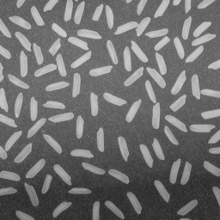

Step 2: Estimate the Value of Background Pixels
In the sample image, the background illumination is brighter in the center of the image than at the bottom. In this step, the example uses a morphological opening operation to estimate the background illumination. Morphological opening is an erosion followed by a dilation, using the same structuring element for both operations. The opening operation has the effect of removing objects that cannot completely contain the structuring element. For more information about morphological image processing, see Morphological Operations.
The example calls the imopen function to perform the morphological opening operation and then calls the imshow function to view the results.. Note how the example calls the strel function to create a disk-shaped structuring element with a radius of 15. To remove the rice grains from the image, the structuring element must be sized so that it cannot fit entirely inside a single grain of rice.
background = imopen(I,strel('disk',15));
figure, imshow(background)

Step 3: View the Background Approximation as a Surface
Use the surf command to create a surface display of the background approximation background. The surf command creates colored parametric surfaces that enable you to view mathematical functions over a rectangular region. The surf function requires data of class double, however, so you first need to convert background using the double command.
figure, surf(double(background(1:8:end,1:8:end))),zlim([0 255]);
set(gca,'ydir','reverse');
The example uses MATLAB indexing syntax to view only 1 out of 8 pixels in each direction; otherwise the surface plot would be too dense. The example also sets the scale of the plot to better match the range of the uint8 data and reverses the y-axis of the display to provide a better view of the data (the pixels at the bottom of the image appear at the front of the surface plot).
In the surface display, [0, 0] represents the origin, or upper left corner of the image. The highest part of the curve indicates that the highest pixel values of background (and consequently rice.png) occur near the middle rows of the image. The lowest pixel values occur at the bottom of the image and are represented in the surface plot by the lowest part of the curve.
The surface plot is a Handle Graphics® object. You can use object properties to fine-tune its appearance. For information on working with MATLAB graphics, see the MATLAB graphics documentation.
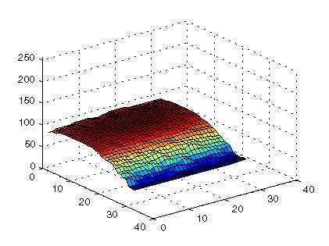

Step 4: Create an Image with a Uniform Background
To create a more uniform background, subtract the background image, background, from the original image, I.
I2 = imsubtract(I,background);
Display the image with its more uniform background.
figure, imshow(I2)

Image with Uniform Background
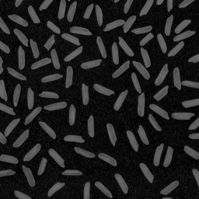

Step 5: Adjust the Contrast in the Processed Image
After subtraction, the image has a uniform background but is now a bit too dark. Use imadjust to adjust the contrast of the image.
I3 = imadjust(I2);
imadjust increases the contrast of the image by saturating 1% of the data at both low and high intensities of I2 and by stretching the intensity values to fill the uint8 dynamic range. See the reference page for imadjust for more information.
Display the adjusted image I3.
figure, imshow(I3);

Image After Intensity Adjustment
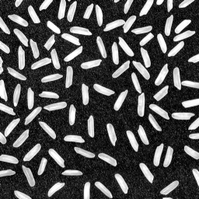

Step 6: Create a Binary Version of the Image
Create a binary version of the image by using thresholding. The function graythresh automatically computes an appropriate threshold to use to convert the grayscale image to binary. The im2bw function performs the conversion.
level = graythresh(I3);
bw = im2bw(I3,level);
figure, imshow(bw)

Binary Version of the Image
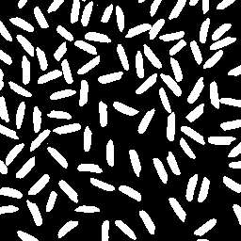
The binary image bw returned by im2bw is of class logical, as can be seen in this call to whos. The Image Processing Toolbox uses logical arrays to represent binary images. For more information, see Binary Images.
whos
MATLAB responds with
Name Size Bytes Class

I 256x256 65536 uint8 array
I2 256x256 65536 uint8 array
I3 256x256 65536 uint8 array
background 256x256 65536 uint8 array
bw 256x256 65536 logical array
level 1x1 8 double array

Grand total is 327681 elements using 327688 bytes

Step 7: Determine the Number of Objects in the Image
After converting the image to a binary image, you can use the bwlabel function to determine the number of grains of rice in the image. The bwlabel function labels all the components in the binary image bw and returns the number of components it finds in the image in the output value, numObjects.
[labeled,numObjects] = bwlabel(bw,4);

numObjects
ans =

101
The accuracy of the results depends on a number of factors, including
- The size of the objects
- Whether or not any objects are touching (in which case they might be labeled as one object)
- The accuracy of the approximated background
- The connectivity selected. The parameter 4, passed to the bwlabel function, means that pixels must touch along an edge to be considered connected. For more information about the connectivity of objects, see Pixel Connectivity.

Step 8: Examine the Label Matrix
To better understand the label matrix returned by the bwlabel function, this step explores the pixel values in the image. There are several ways to get a close-up view of pixel values. For example, you can use imcrop to select a small portion of the image. Another way is to use toolbox Pixel Region tool to examine pixel values. Display the label matrix, using imshow,
figure, imshow(labeled);
Start the Pixel Region tool.
impixelregion
By default, it automatically associates itself with the image in the current figure. The Pixel Region tool draws a rectangle, called the pixel region rectangle, in the center of the visible part of the image. This rectangle defines which pixels are displayed in the Pixel Region tool. As you move the rectangle, the Pixel Region tool updates the pixel values displayed in the window. For more information about using the toolbox modular interactive tools, see Building GUIs with Modular Tools.
The following figure shows the Image Viewer with the Pixel Region rectangle positioned over the edges of two rice grains. Note how all the pixels in the rice grains have the values assigned by the bwlabel function and the background pixels have the value 0 (zero).

Examining the Label Matrix with the Pixel Region Tool
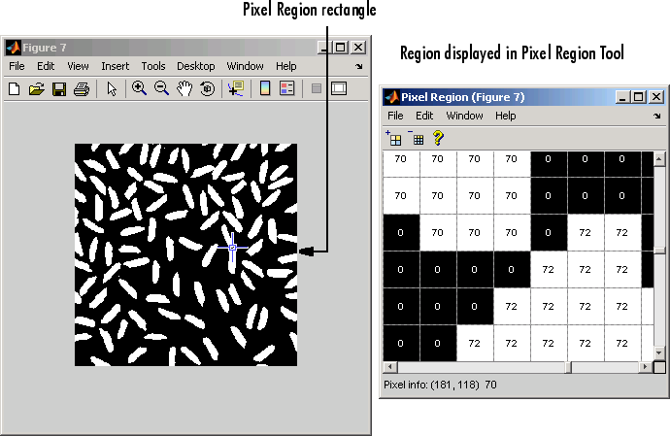

Step 9: Display the Label Matrix as a Pseudocolor Indexed Image
A good way to view a label matrix is to display it as a pseudocolor indexed image. In the pseudocolor image, the number that identifies each object in the label matrix maps to a different color in the associated colormap matrix. The colors in the image make objects easier to distinguish.
To view a label matrix in this way, use the label2rgb function. Using this function, you can specify the colormap, the background color, and how objects in the label matrix map to colors in the colormap.
pseudo_color = label2rgb(labeled, @spring, 'c', 'shuffle');
imshow(pseudo_color);

Label Matrix Displayed as Pseudocolor Image
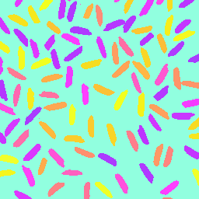

Step 10: Measure Object Properties in the Image
The regionprops command measures object or region properties in an image and returns them in a structure array. When applied to an image with labeled components, it creates one structure element for each component.
The following example uses regionprops to create a structure array containing some basic properties for labeled. When you set the properties parameter to 'basic', the regionprops function returns three commonly used measurements: area, centroid (or center of mass), and bounding box. The bounding box represents the smallest rectangle that can contain a region, or in this case, a grain of rice.
graindata = regionprops(labeled,'basic')
MATLAB responds with
graindata =

101x1 struct array with fields:
Area
Centroid
BoundingBox
To find the area of the 51st labeled component, access the Area field in the 51st element in the graindata structure array. Note that structure field names are case sensitive.
graindata(51).Area
returns the following results
ans =

140
To find the smallest possible bounding box and the centroid (center of mass) for the same component, use this code:
graindata(51).BoundingBox, graindata(51).Centroid
ans =

107.5000 4.5000 13.0000 20.0000

ans =

114.5000 15.4500

Step 11: Compute Statistical Properties of Objects in the Image
Now use MATLAB functions to calculate some statistical properties of the thresholded objects. First use max to find the size of the largest grain. (In this example, the largest grain is actually two grains of rice that are touching.)
max([graindata.Area])
returns
ans =

404
Use the find command to return the component label of the grain of rice with this area.
biggrain = find([graindata.Area]==404)
returns
biggrain =

59
Find the mean of all the rice grain sizes.
mean([graindata.Area])
returns
ans =

175.0396
Make a histogram containing 20 bins that show the distribution of rice grain sizes. The histogram shows that the most common sizes for rice grains in this image are in the range of 150 to 250 pixels.
hist([graindata.Area],20)
